# FarmFresh Supermarket

#Entity Relationship Diagram

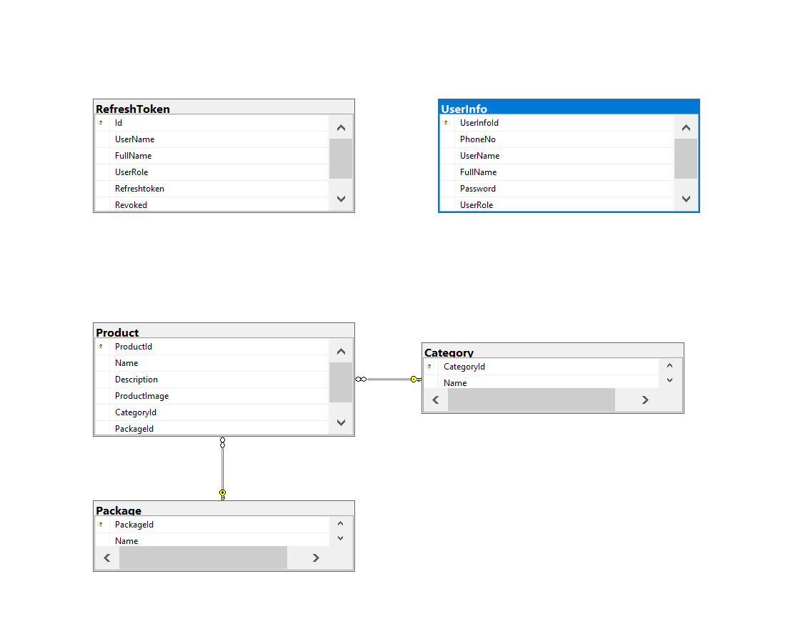

#Sequence Diagram

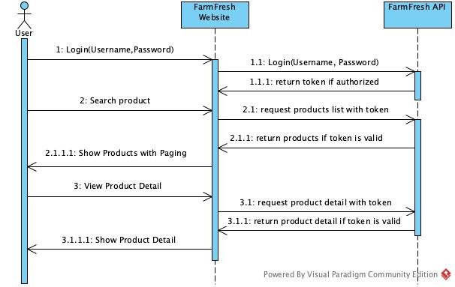

#API Documentation

Username: aung

Password: 1234

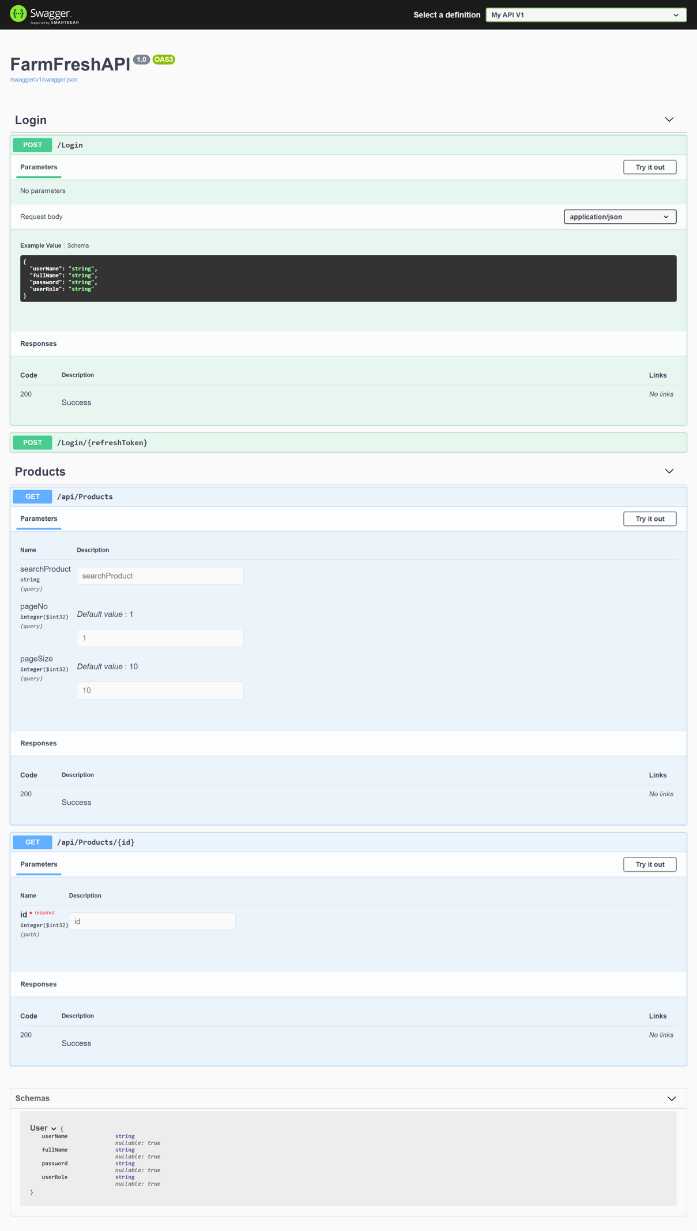

#Landing Page

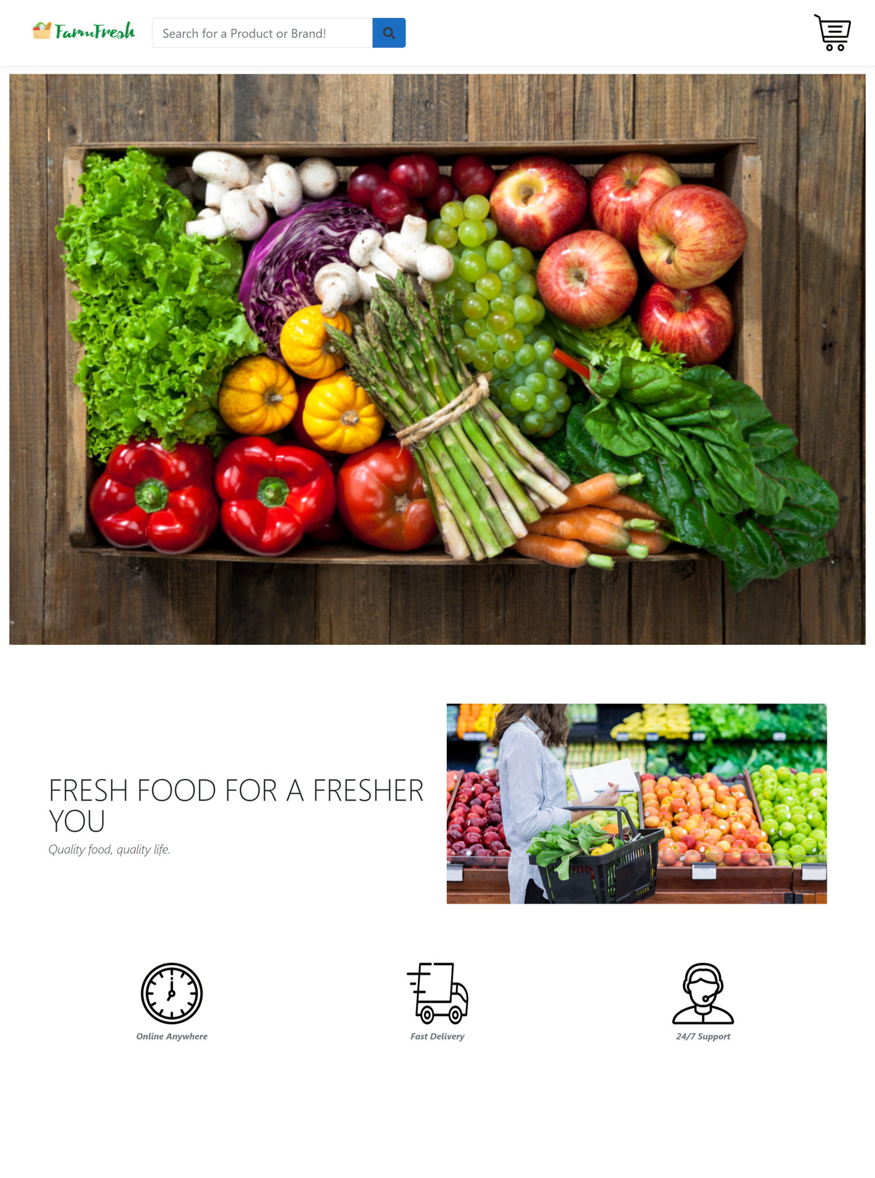

#Product List Page

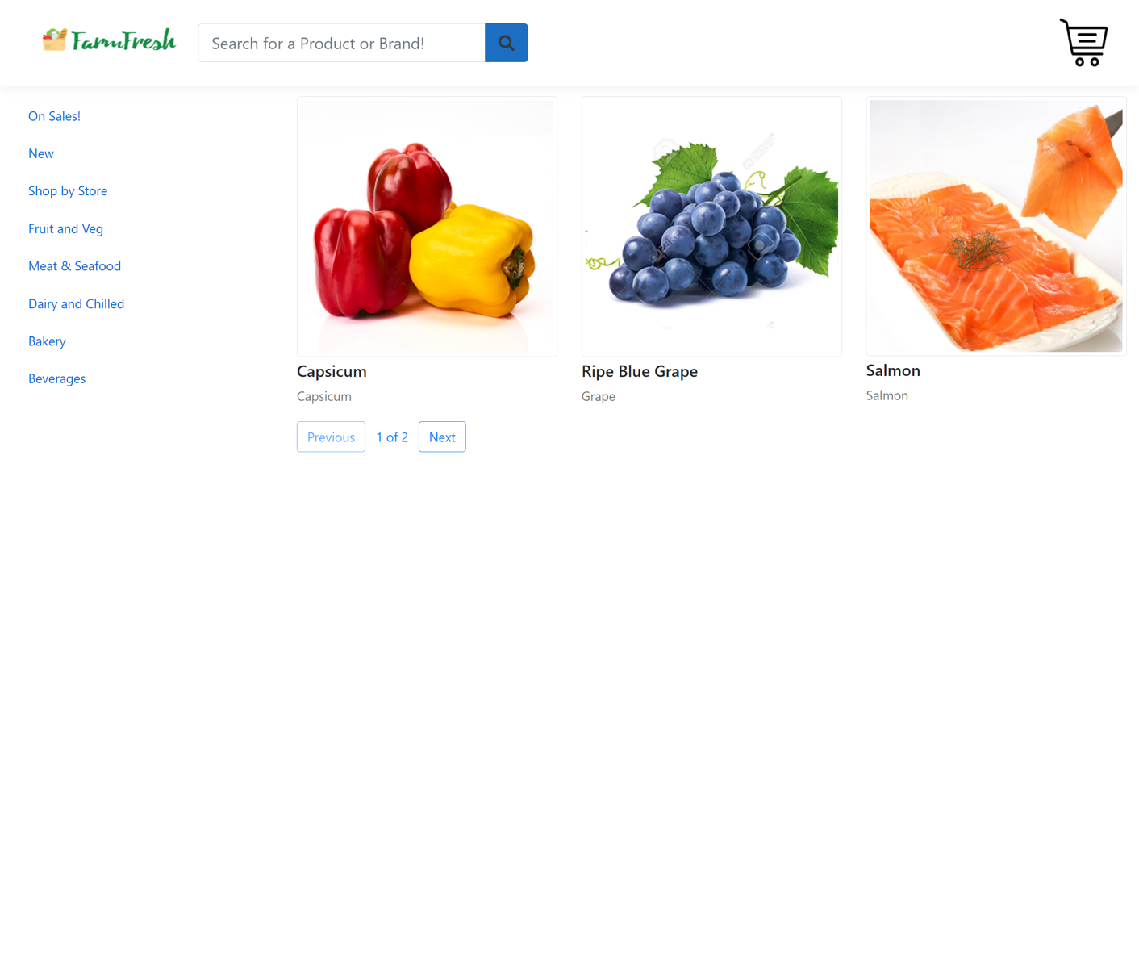

#Product Detail Page

